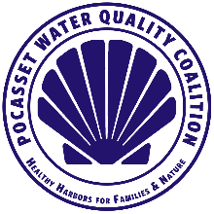 | Pocasset Water Quality Coalition  Member Newsletter  November/December 2021

Happy Holidays!!!
This is another newsletter to keep everyone up to date on developments to improve Pocasset’s water quality.

The Big news in Bourne is that the Special Town Meeting in November overwhelmingly voted to reject the proposal to build a larger treatment plant at the Massachusetts Merchant Marine Academy. This larger treatment plant proposal intended to dump effluent into the canal. This was not a binding article, but the message sent to Town Boards was strong. It was a voice vote, so just guessing over 400 voted to reject the plan, maybe 25 supported it. I spoke at the meeting on behalf of PWQC in favor of rejecting the plan. I received many positive comments for our position. One person said to me in person a few days after the meeting; “Great job, thank you so much for speaking up”.

The PWQC Board has been working for a couple of months now to research SAFE fertilizers for our lawns. Nitrogen runoff is a known key contributor to the level of algae in the water, and the related impact on the declining water quality. While towns and various community groups are exploring grander systemic solutions to nitrogen, we are looking at what we as individuals can do. One thing is to become informed about safer alternatives to the more common products on the market.
We are VERY close to have some specific recommendations. If you are asked to commit to your providers for 2022, please wait. We are exploring various products and local distributors so we can provide a listing of options. As a nonprofit, we have to avoid recommending a specific business. However, if we research multiple options and provide this information, we can avoid any risk to our non-profit status. There will be more detailed news in our January Newsletter.

Several members of the board have been conducting site visits, researching innovations to address water quality, and getting advisement from others dedicated to improving and sustaining the quality of our waterways. In the last newsletter, we described the visit to Shubael Pond, a NitROE pilot testing site in Barnstable.
This month, we describe the visit three board members (Ken Pearson, Keith Barber, and Bob Dwyer) made to the Massachusetts Alternative Septic System Test Center (MASSTC) in early November.
MASSTC was founded in 1999 and is a leading test facility for innovative septic system technologies located on Joint Base Cape Cod in Sandwich, MA. The research performed here has been instrumental in providing a better understanding of how viruses, bacteria, environmentally hazardous nutrients such as Nitrogen, Phosphorous, and other contaminants of concern can be treated, before they make their way into our drinking water and aquatic ecosystems.
Due to the nature of these systems, most of the structures are buried underground. Our tour included a walk around and discussions of the various types of technologies, their purpose and performance ratings. All the systems are supplied by raw sewage from 250 homes and other institutions in the area. Their performance is monitored and recorded daily.
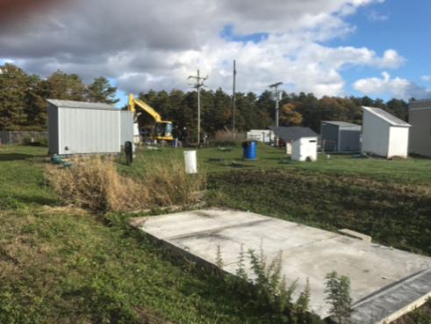
The group also learned of the several types and sizes of Layer Cake Systems. They are constructed of layers of sand and sawdust or woodchips. Some are saturated with water to create an anoxic environment that supports certain types of bacteria that remove contaminants. Some are gravity fed so they require minimal power to run.

The board plans to continue setting up these “field trips” and welcomes participation from our membership. If you are interested in attending, let us know by emailing us and we will put you on a call list for when these events get scheduled. This is a fun way to become more involved, learn very interesting facts about this important issue, and hear from experts in the field.

As we close 2021, we want to thank you to everyone for paying your $20 dues. As we move into the third year of the Pocasset Water Quality Coalition, your support is so necessary. PWQC dues can be paid on our website under the Donate tab www.pocassetwaterquality.org or by mail to: PWQC PO Box 852 Pocasset, MA 02559.
Have a great Holiday Season,
The Pocasset Water Quality Board of Directors
Chris Bade, Keith Barber, Deanna Doucette, Bob Dwyer, Frank Gasson, Martha Hoefer, Ken Pearson, Jerry Struzik, and Bill Veno
____________________________________________________________________________________
Visit our web page at to keep current with the activities of the PWQC and how you can help be part of the solution!
www.pocassetwaterquality.org

