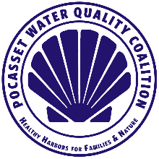 | Pocasset Water Quality Coalition  Member Newsletter – January/February 2022  www.pocassetwaterquality.org

Friends and neighbors,

As the saying goes, “Knowledge is power.” This quote from the 16th century is more important now than ever. Access to information is the main way we can make a difference. Recognizing this, one of PWQC’s goals for 2022 is to increase educational opportunities for everyone.

Improvements to website
Toward that end, our website www.Pocassetwaterquality.org has been improved by adding a Library tab. The Library tab includes links to important and informative articles designed to help us all better understand our water quality plight. In addition, any articles referencing the PWQC are filed there.
This will be the first Newsletter to be available only on our website. Rest assured, we will continue to update members through email and a reminder to check out the most recent Newsletter.

Hot topic: Mass Maritime Academy wastewater treatment plant
Developments around the Massachusetts Maritime Academy (MMA) wastewater treatment plant (WWTP) have become an important topic locally. The EPA permit to allow effluent from the MMA WWTP to be released into the Cape Cod Canal is up for renewal. Being all too familiar with the fact that whatever goes into the Canal effects our salt water, we believed PWQC should voice our opinion.
PWQC Board Vice President Dr. Bob Dwyer wrote an opinion that was posted during the comment period of the renewal process to the EPA. Our Board recommended that appropriate Bourne Town Government officials as well as local media be included and copied on this opinion document.
As a result, an article appeared in the Cape Cod Times in response to our viewpoint. Following is a link to the article. Link is also in Library on www.Pocassetwaterquality.org.
https://www.capecodtimes.com/story/news/2022/02/12/water-quality-coalition-epa-concern-mass-maritime-cape-cod-canal-sewage-disposal/6750948001/

Hot topic: Fertilizer runoff
As stated in our December newsletter, fertilizer runoff and its migration through soil to the water is the #2 contributor to harmful nitrogen in our water. Our objective is to reduce / eliminate excessive use of nitrogen-loaded chemical products that we or our lawn-care specialists use. While the perfect product doesn’t yet exist, we should move toward organic nitrogen products which can improve soil structure and aeration while increasing water retention abilities and stimulating healthy root development.
Three (3) alternatives everyone can use for their lawns and gardens.
- Soil conditioners, all organic, are the most environmentally friendly. In the PWQC Library on our website there are two soil conditioner options. One company, Cape Tree Preservation, will come to your property and apply soil conditioner.
- Inform your lawn-care provider you want to use soil conditioner versus chemicals on your lawn. One product, Fish Brew soil conditioner, is a liquid to be sprayed on your lawn and is produced by Blue Stream Aquaculture in Barnstable. You can also buy this product to spray on your lawn yourself.
- Apply Jonathan Green organic fertilizer. Able to be applied with your own spreader, Jonathan Green offers a 4-step plan similar to “other” fertilizer makers. This product is available at Pocasset Hardware on Barlow’s Landing Rd.
Please note: Soil conditioners do not work like traditional chemical fertilizers. Rather, they are long-term, slow-acting products. In the PWQC Library on our website there are links to all three (3) alternatives.

Upcoming events:
- Comprehensive Wastewater Management Plan: The Town of Bourne is in the process of developing a Comprehensive Wastewater Management Plan. As a result, the Bourne Sewer Commission has created a Wastewater Advisory Committee. PWQC Board member, Keith Barber has been appointed as one of the South of the Canal representatives. To learn more, go to the Town of Bourne website and click on the Comprehensive Wastewater Management Plan tab.
- PWQC Annual Meeting - Sat., Aug. 13, 10 a.m. PHIA Building across from the boat ramp on Circuit Avenue.
- PWQC 2022 Annual dues will again be $20. Go to the Donate tab on our website www.Pocassetwaterquality.org or mail a check to PWQC PO Box 852 Pocasset, MA 02559. Thank you for your continued support.

That is all for now. Spring is in the air…enjoy!

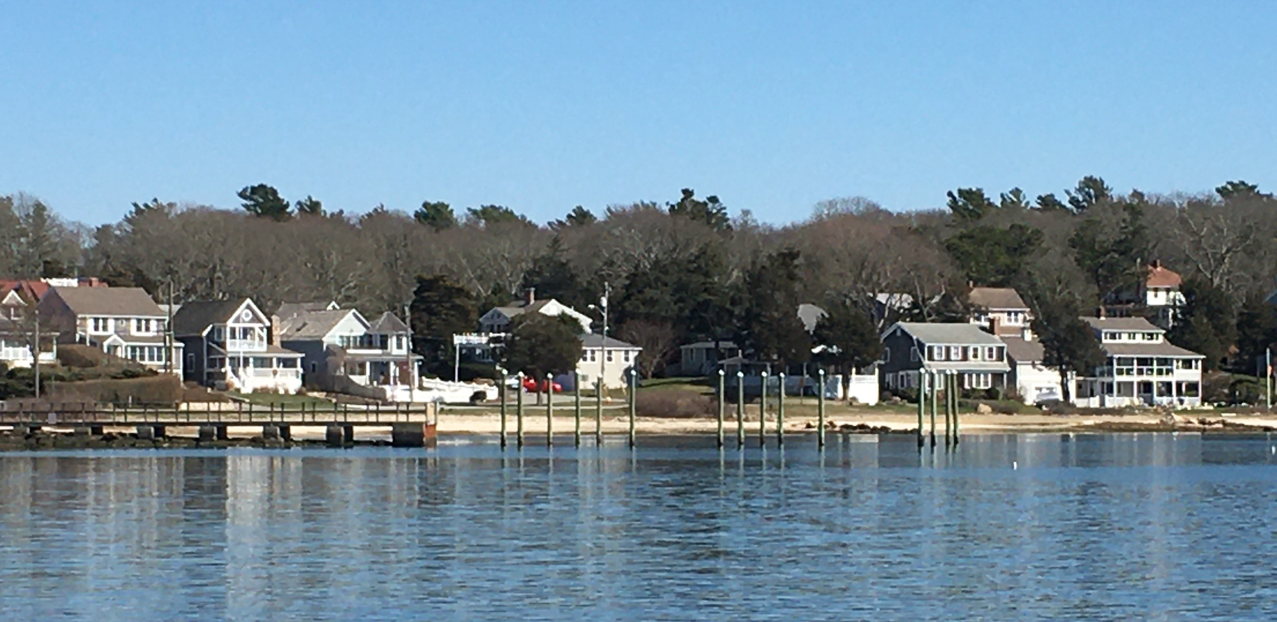

The Pocasset Water Quality Board of Directors
Chris Bade, Keith Barber, Deanna Doucette, Bob Dwyer, Frank Gasson, Martha Hoefer, Ken Pearson, Jeff Sawyer, Jerry Struzik, and Bill Veno

__________________________________________________________________________________
Visit our website to keep current with the activities of the PWQC and how you can help be part of the solution!
www.pocassetwaterquality.org

